**Title: Raster Data Analysis**

**What you will learn:**

* Preparing the data
* Terrain analysis
* Reclassification
* Using the Raster Calculator

**Resources:**

* Data for this exercise is in the data7 folder (**UNZIP** the folder after downloading).

**Laboratory Exercise:**

In this exercise, you are tasked to identify the potential site for vineyards somewhere in Denmark. The ideal vineyard location should have the following characteristics:

* Then landcover must be grassland or cropland
* The site must be on south-facing moderate slopes

You will begin by processing rasters to prepare them for analysis. This will include clipping them to a study area and reprojecting them to a common coordinate reference system. You will then learn about topographic data and how to perform terrain analysis.

For this exercise, you will use the following data:

* dtm.tif – a raster dataset with every pixel having a numeric value representing the elevation above mean sea level in meters.
* ESA_worldcover.tif – a raster dataset with every pixel having a numeric value that corresponds to a particular landcover category.
* Study_area.shp – a vector layer with a rectangular geometry representing the extent of the study area.

**Deliverables:**

* Printable map showing the terrain with contours.
* Printable map showing the suitable sites for vineyards.

**Procedure:**

Important: Create a folder (call it lab7) to store the maps that you create during the exercise

***Part 1 – Preparing the Terrain map***

The *dtm* and the *ESA_worldcover* layers cover larger areas than the study area. The first thing that we have to do is to extract the data within the study area. If we are dealing with vector data, we would clip it. Here, we will use a different technique to achieve the same result as the raster dataset.

*1.1 Clip the dtm to the study area*

1. Right-click on the dtm layer in the Layers panel then choose Export – Save As.

2. On the Save Raster Layer as window, specify the following (Figure 1):

* File name: terrain – browse to your lab7 folder and type the file name
* Extent: Calculate from *Layer*, then choose the *study_area* layer – To accomplish the equivalent of a clip, you will change the *Extent* (i.e., the area covered) basing it on the study area extent. You will see the coordinates change when you do this.
* Resolution: 2 m for both vertical and horizontal.
* OK
* Right-click on the dtm layer in the Layers panel and remove it.

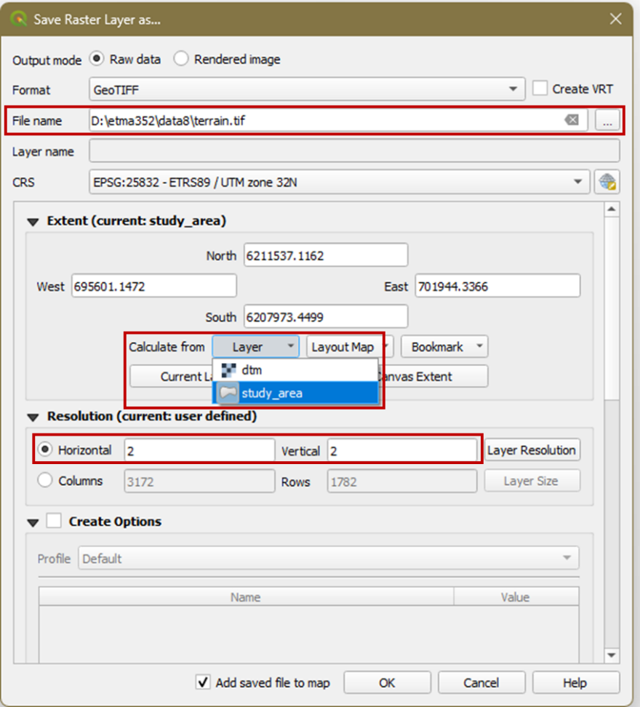

Figure . Exporting a raster layer to a different extent

*1.2 Styling the Terrain*

1. Open the Layer Styling panel  and set the target layer to terrain (Figure 2).

2. Change the renderer from Singleband gray to Hillshade. Now the terrain is rendered as a hillshade(Figure 3). Hillshading is a method of illuminating the elevation map from a specific direction and angle above the horizon, enabling you to visualize the terrain intuitively. If you zoom in, you can see some pixelization. You can smooth that by choosing a different resampling method.

3. Under Resampling, choose Bilinear for both Zoomed in and Zoomed out.

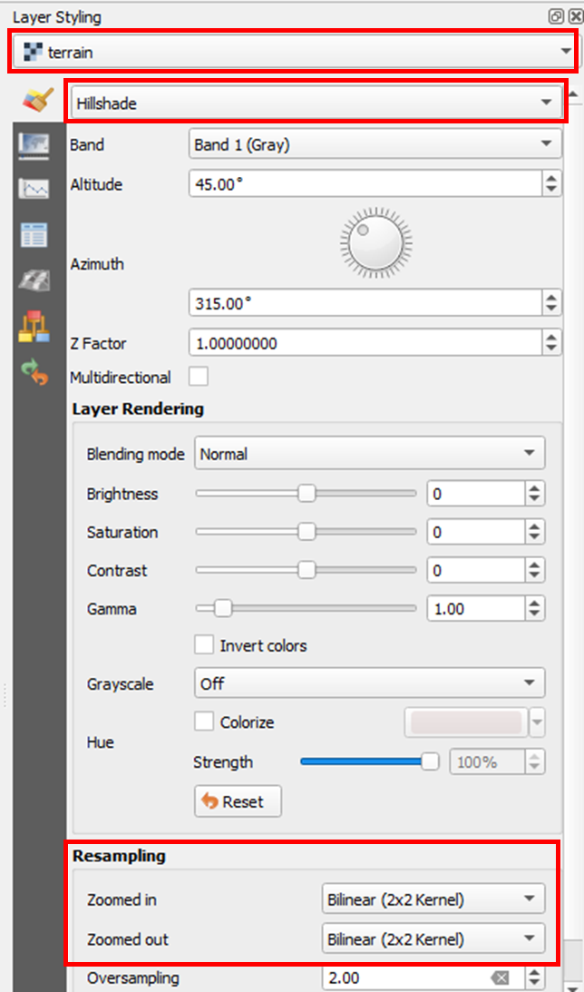

Figure . Styling the terrain

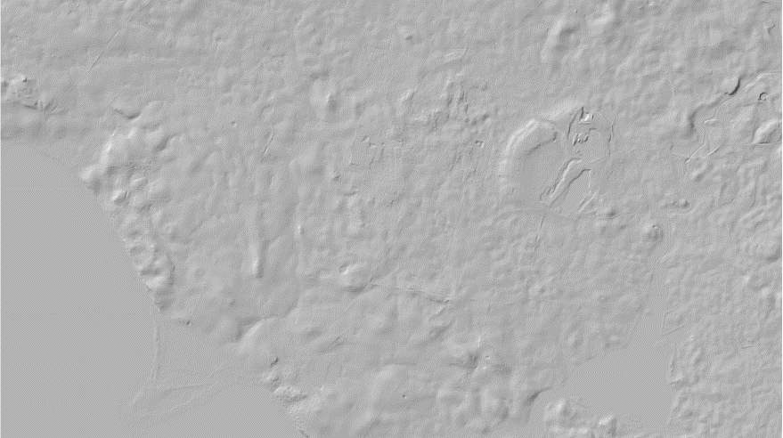

Figure 3. Hillshade of the terrain

4. Rename the terrain layer to Hillshade (right-click – rename – change name in the Layer panel).

5. Right-click on the Hillshade layer and choose Duplicate layer.

6. Rename the Hillshade copy layer to dtm. Temporarily turn off (i.e., uncheck in the Layers panel) the Hillshade layer and let us style the dtm layer.

7. Open the Layer Styling panel (if you closed it) and change target layer to dtm.

8. Change the rendered from Hillshade to Singleband pseudocolor. There are many color ramps to choose from but you will load one specifically for topography.

9. Click the dropdown arrow of the Color ramp and choose Create New Color Ramp (Figure 4a).

10. On the color ramp type, select Catalog: cpt-city and click OK (Figure 4b)

11. The cpt-city Color Ramp window opens with categories on the left side (Figure 4c). Choose Topography and select the palette that you like. Click OK to accept.

12. You may have to click Classify in the Layer Styling panel to get the new color ramp to fully load.

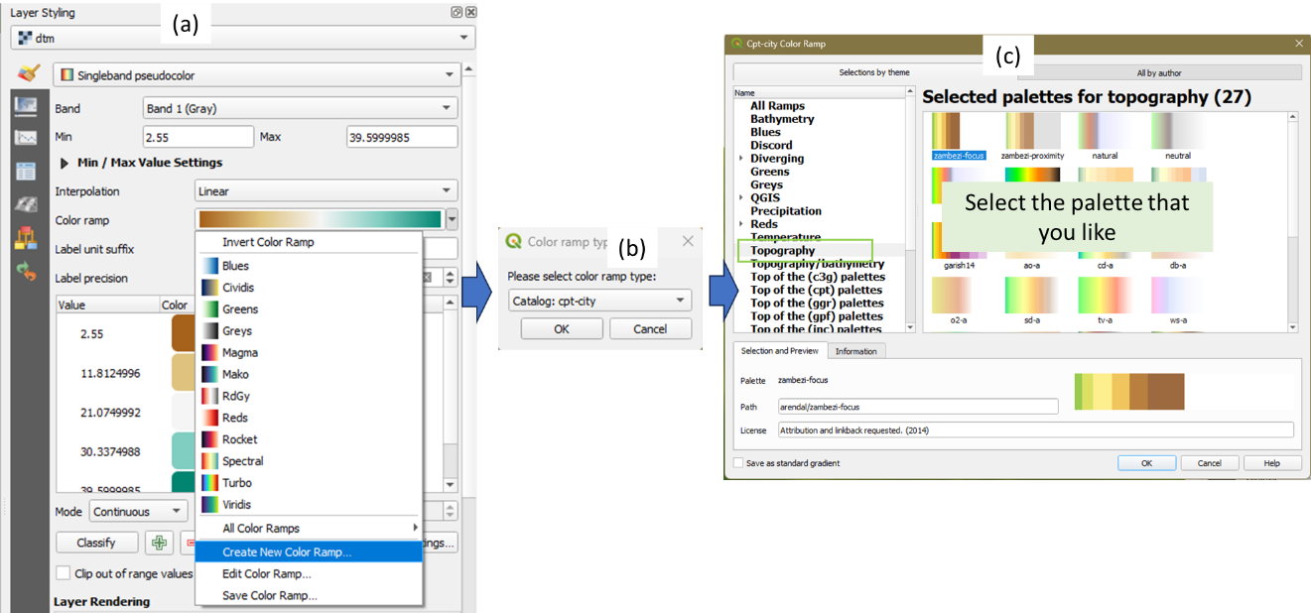

Figure 4. Styling the dtm layer

13. Now turn the Hillshade layer back on. It obscures the colored dtm layer. Make the Hillshade layer the target layer in the Layer Styling panel.

14. Under the Layer Rendering section, change the Blending mode from Normal to Multiply (Figure 5). This will give you a nice color hillshade effect.

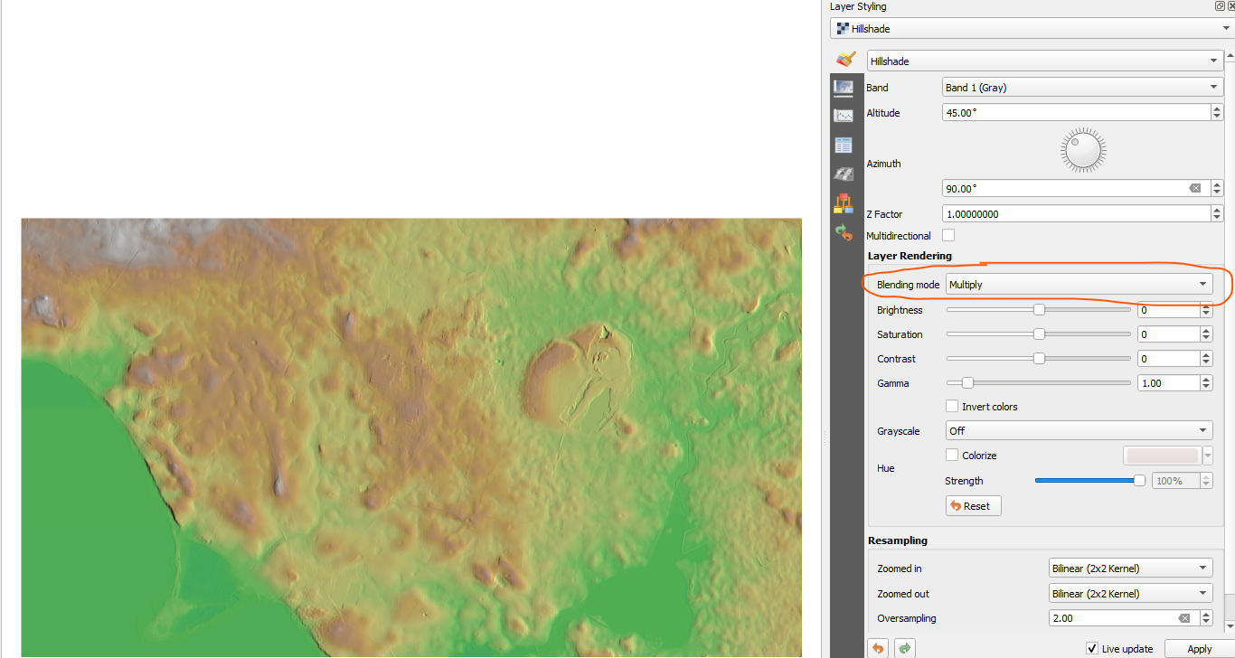

Figure 5. Changing the blending mode of the hillshade

Now you will learn to use the Contour renderer.

15. Duplicate the Hillshade layer and rename the copy Contour. Drag the Contour layer so that it is above the Hillshade in the Layers panel.

16. From the Layer Styling panel, change the target layer to Contour and change the renderer from Hillshade to Contours.

17. Change the following elements in the Layer Styling panel (Figure 6):

* Contour interval = 2
* Index Contour interval = 10
* Click on the Index Contour Symbol and increase the Stroke width to 0.66 mm. Click the back button to go back to Symbol Settings.
* Change the Blending mode to Overlay.

18. The map in Figure 6 is the final map of the terrain.

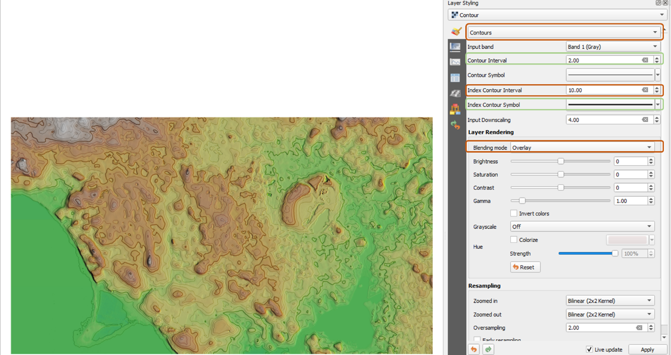

Figure 6. Styling the Contour layer

***Part 2 – Preparing the Land Cover map***

Like the dtm layer, the ESA_worldcover layer is larger than the study area. In addition, the landcover is in different CRS than the rest of the layers. You will first extract (or clip) the landcover within the study area and then reproject it to EPSG:25832 CRS which is the CRS of the other rasters.

*2.1 Clip the land cover to the study area*

1. Right-click on the ESA_worldcover layer and choose Export – Save As.

2. On the *Save Raster Layer as* window, specify the following (Figure 7):

* File name: landcover – browse to your lab7 folder and type the file name
* CRS: click the dropdown arrow in CRS and choose Project CRS: EPSG:25832 – ETRS89/UTM zone 32N.
* Extent: Calculate from *Layer*, then choose the *study_area* layer – You will see the coordinates change when you do this.
* Resolution: 2 m for both vertical and horizontal. This is the same resolution as the terrain layer.
* OK

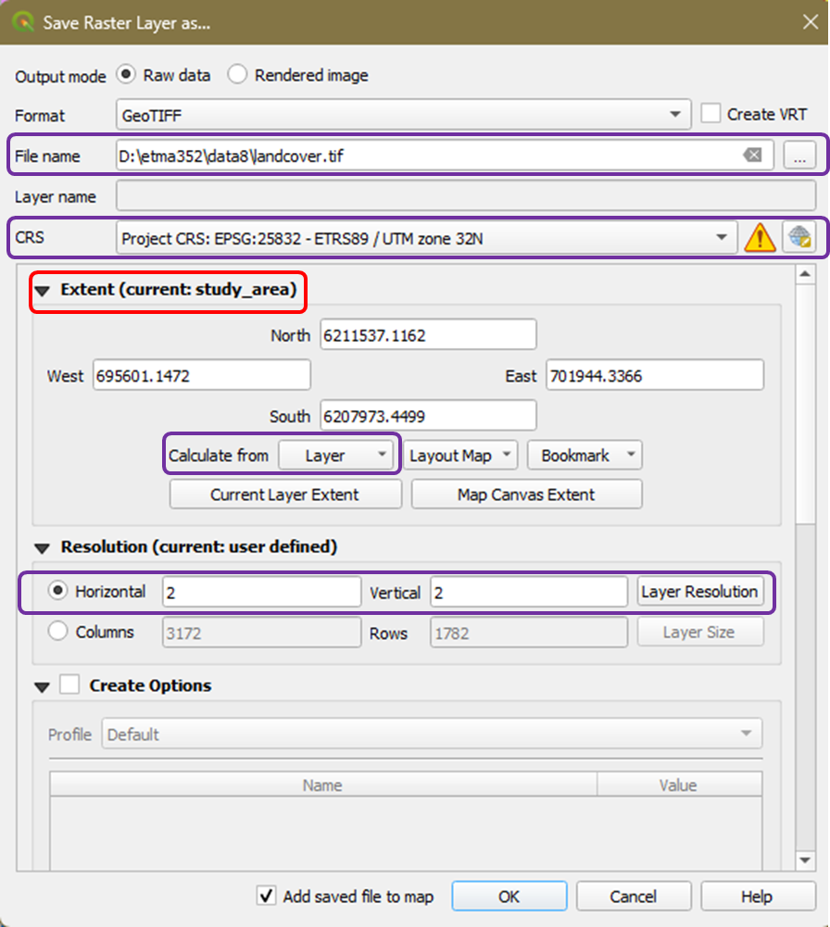

Figure 7. Clipping the landcover

*2.2 Styling the Landcover layer*

1. Right-click on the original ESA_worldcover layer and choose Styles – Copy style from the context menu.

2. Right-click on the landcover layer and choose Styles – Paste style. You have now transferred the style of the original layer to the new layer.

3. Right-click on the ESA_worldcover layer in the Layers panel and remove it.

4. Right-click on the landcover layer in the Layers panel then choose Properties.

5. In the Layer Properties window, click the Symbology tab. At the bottom of the window, click the Style drop-down arrow and choose Load style (Figure 8a). The Database Styles Manager window opens.

6. In the Database Styles Manager window, specify the following (Figure 8b):

* Load style: click the dropdown arrow and choose From file
* File: Browse to the Style folder within the data7 folder and select 
* Click Load Style to close the window.

7. Click OK to accept and close the Layer Properties window.

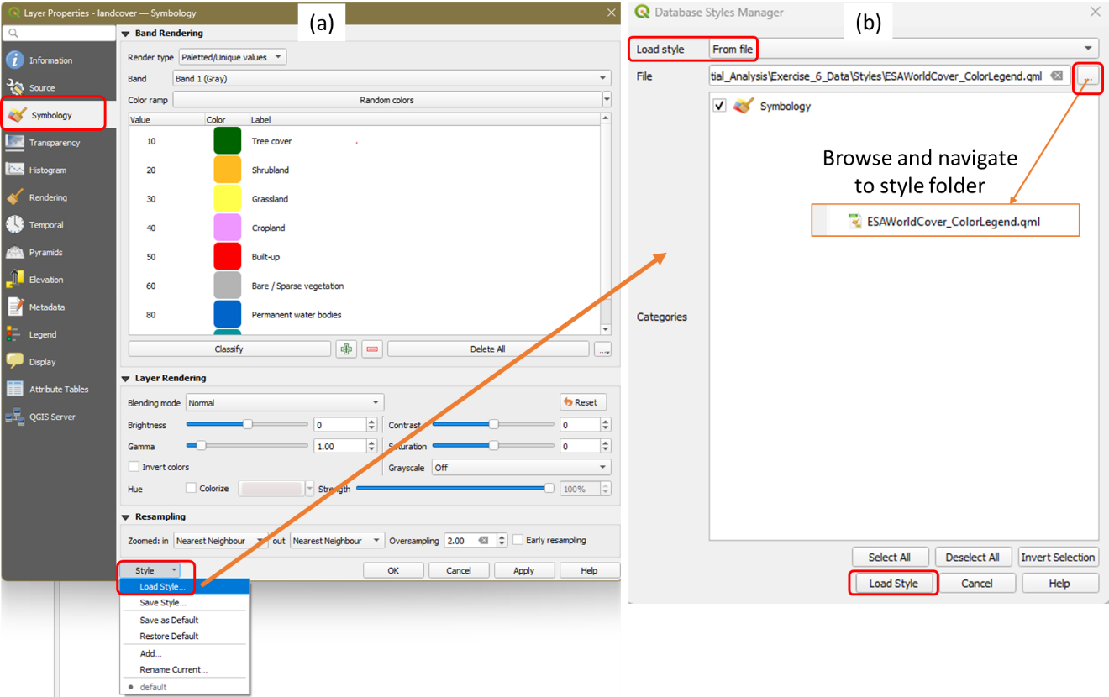

Figure 8. Styling the landcover layer

6. The styled landcover layer should have its original colors restored and should now include description of the land cover (Figure 9).

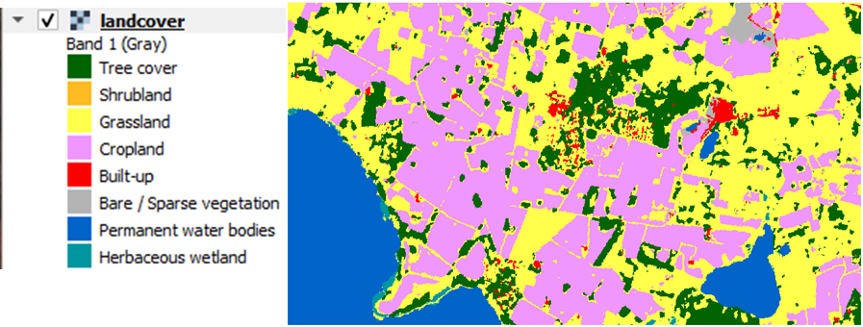

Figure 9. Style landcover layer

*2.3 Reclassify the Landcover layer*

The landcover layer will be reclassified into 1’s and 0’s. Here the values of 1 will represent suitable land cover (i.e., grass and cropland), and 0’s will represent unsuitable areas (i.e., the rest of the landcover categories). You will also use this to identify which areas of suitable slope and aspect are also on suitable land cover.

Click the Layer Styling  icon and set the target layer as the *landcover* layer. You can see that the *landcover* layer has eight classes with numerical values corresponding to each class (see Figure 10). We will reclassify the values so that classes 30 and 40 will become 1 and the rest 0.

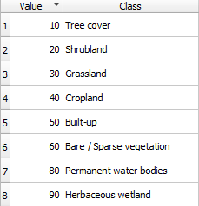

Figure 10. Values of the landcover classes

1. From the main menu, choose Processing – Toolbox – Raster analysis – Reclassify by table. The Reclassify by Table window opens.

2. In the Reclassify by Table window, specify the following (Figure 11):

* Raster layer: landcover
* Reclassification table: Click the browse button to the right of the Reclassification table to create the reclassification table. Here you will reclassify the landcover classes to 1’s and 0’s.
  + Click the *Add Row* button. Double-click on the cells to type values
  + For *Minimum* enter 10, for *Maximum* enter 10, and for *Value* enter 0. This tells QGIS to make any pixels with the value equal to 10 (i.e., tree cover) to change the value to 0.
  + Click the *Add Row* button again. This time enter a *Minimum* of 20 (for Shrubland), a *Maximum* of 20, and a *Value* of 0.
  + Continue until you have completed the table as shown in Figure 11b and click OK.
* You should see the Reclassification table as Fixed table (8x3) (Figure 11a).
* Expand the Advanced Parameters section (Figure 11a).
  + Set the *Range boundaries* to min <= value <= max
  + Check the *Use NoData when no range matches value.*
  + Set the Output data type to Int16
* Reclassified raster: Save to File and name it landcover_rc
* Run

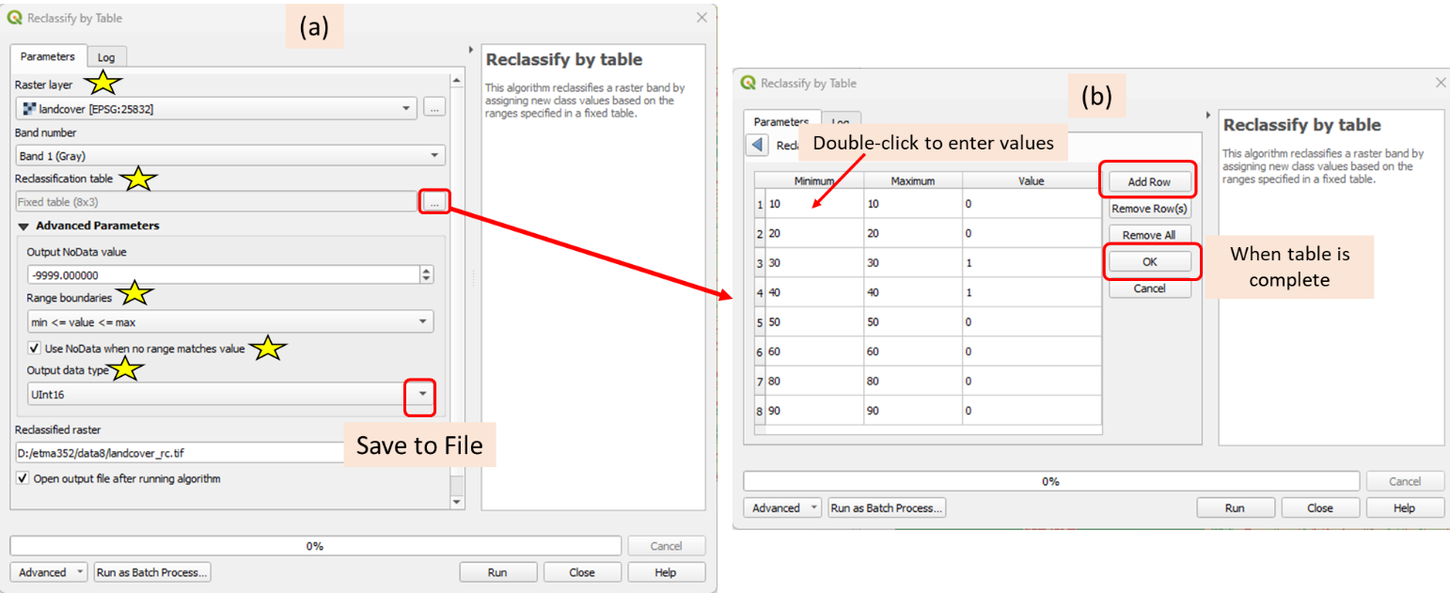

Figure . Reclasscifying the landcover layer

*2.3 Style the reclassified landcover*

1. Style the reclassified landcover layer to make it more intuitive. Open the Layer Styling panel and choose the following:

* Target layer: landcover_rc
* Render type: Paletted/Unique values
* Color ramp: Click the downward arrow and select All Color Ramps then use RdY|Gn
* Click *Classify*
* The styled reclassified landcover layer should look like in Figure 12.

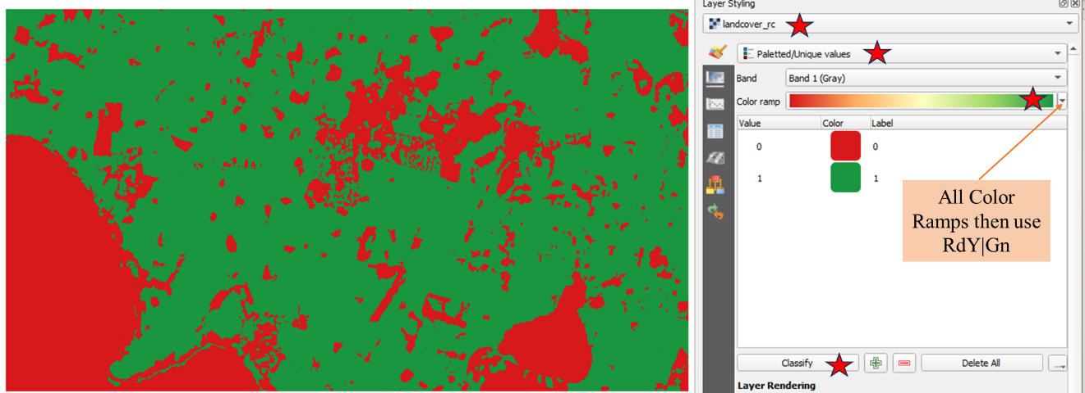

Figure . Reclassified and styled landcover layer

***Part 3 – Terrain Analysis***

Two parameters that will be used to determine the best location for a vineyard are slope and aspect. **Aspect** measures which cardinal direction the terrain in each pixel is facing (i.e., north-facing vs south-facing) while **Slope** measures the steepness of the terrain. These parameters can be generated from the dtm layer. You will use the Raster Terrain Analysis toolset to create these elevation-related datasets. You will then reclassify these maps and style them accordingly.

*3.1 Creating the Slope layer*

The next requirement for the vineyard is to have a moderate slope. We will compute the slope from the dtm, reclassify the values to identify which pixels have moderate slopes, and style the reclassified slope layer.

1. From the main menu, choose Processing – Toolbox

2. Find the *Raster terrain analysis* section, expand it, and double-click on *Slope* (Figure 13). This will open the Slope algorithm window that allows you to create a slope dataset.

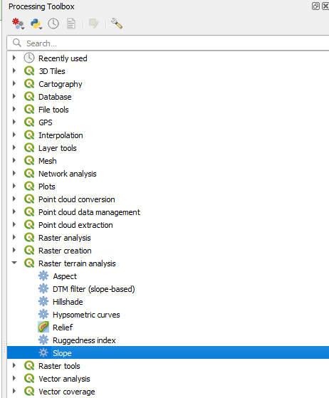

Figure 13. Access the slope algorithm

3. On the Slope algorithm window, specify the following (Figure 14)

* Elevation layer: dtm
* Z factor = 1
* Slope: Click the dropdown arrow and choose Save to File. Navigate to the lab7 folder and name the file “slope”.
* Run
* Close

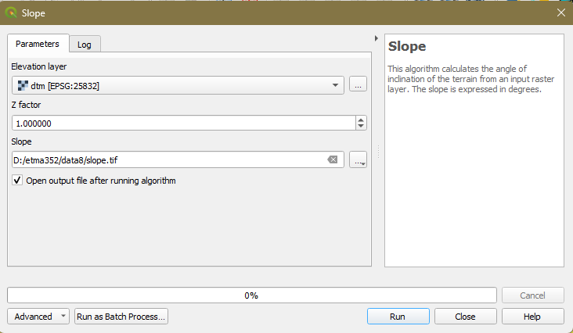

Figure 14. Slope algorithm window

*3.2 Reclassify Slope*

The slope will be reclassified on a scale of 1 to 4. Values of 4 will represent moderate slopes while 1’s are either too flat or too steep.

1. From the main menu, choose Processing – Toolbox – Raster analysis – Reclassify by table. The Reclassify by Table window opens.

2. In the Reclassify by Table window, specify the following (Figure 15):

* Raster layer: slope
* Reclassification table: Click the browse button to the right of the Reclassification table to create the reclassification table. Here you will create slope classes to where the slope values in the pixels will go.
  + Click the *Add Row* button. Double click
  + For *Minimum* enter 0
  + For *Maximum* enter 1
  + For *Value* enter 1 (This tells QGIS to make any slope pixels with the value from 0 to 1 an output value of 1).
  + Click the *Add Row* button again. This time enter a *Minimum* of 1, a *Maximum* of 3, and a *Value* of 2.
  + Continue until you have completed the table as shown in Figure 15b and click OK.
* You should see the Reclassification table as Fixed table (7x3) (Figure 15a).
* Expand the Advanced Parameters section (Figure 15a).
  + Set the *Range boundaries* to min < value < = max
  + Check the *Use NoData when no range matches value.*
  + Set the Output data type to Int16
* Reclassified raster: Save to File and name it slope_rc
* Run

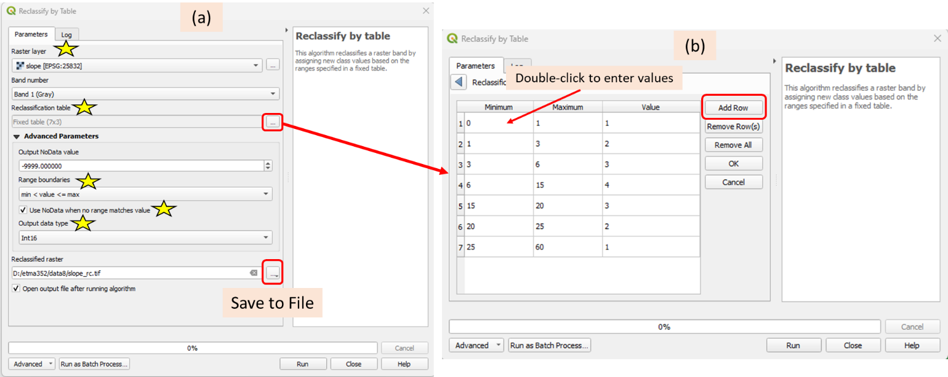

Figure 5. Slope Reclassification Algorithm

*3.3 Styling the reclassified slope layer*

1. Style the slope_rc layer using the Layer Styling  icon as follows (Figure 16):

* Target layer: slope_rc
* Render type: Paletted/Unique values
* Color ramp: Click the downward arrow and select All Color Ramps then use RdY|Gn
* Click *Classify*
* The slope_rc layer should look like in Figure 16.

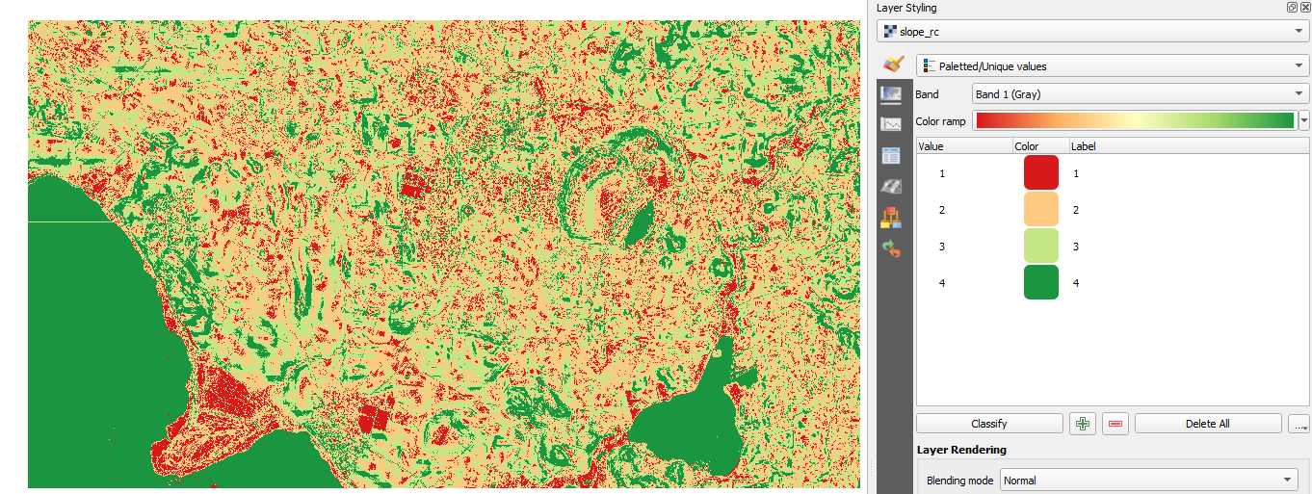

Figure 16. Reclassified and styled slope layer

*3.4 Creating the Aspect layer*

1. From the main menu choose *Processing – Toolbox – Raster terrain analysis* then double-click on *Aspect.*

2. On the *Aspect* algorithm window, specify the following (Figure 17).

* Elevation layer: dtm
* Z factor = 1
* Aspect: Click the dropdown arrow and choose Save to File. Navigate to the lab7 folder and name the file “aspect”.
* Run
* Close

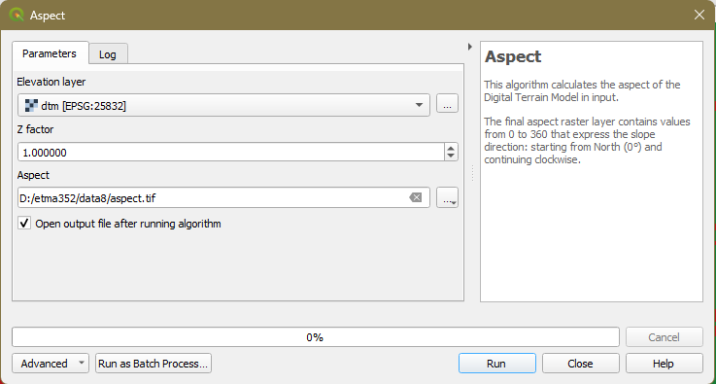

Figure 17. Aspect algorithm window

3. Notice that the output has values from 0-360 representing degrees (0 = north, 90 = east, 180 = south, and 270 = west).

*3.6 Reclassify Aspect*

The aspect will be reclassified on a scale of 1 to 4. Figure 18 shows what the aspect raster values mean. For example, south-facing slopes have aspect values ranging from 135 (midpoint between 90 and 180) to 225 degrees. Here you will reclassify the aspect to weighting south-facing slopes as most ideal with an output value of 4, and north-facing slopes as least ideal with an out value of 1.

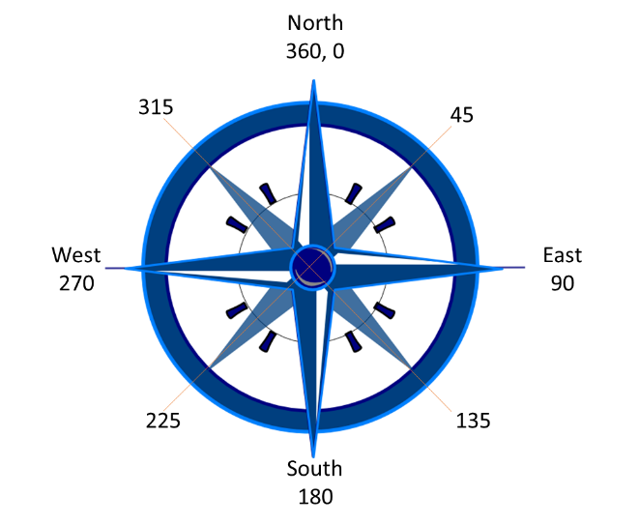

Figure . Aspect

1. From the main menu, choose Processing – Toolbox – Raster analysis – Reclassify by table. The Reclassify by Table window opens.

2. In the *Reclassify by Table* window, specify the following (Figure 19):

* Raster layer: aspect
* Reclassification table: Click the browse button to the right of the Reclassification table to create the reclassification table. Here you will create aspect classes to where the aspect values in the pixels will go.
  + Click the *Add Row* button. Double-click on the cell to edit values.
  + For *Minimum* enter 135
  + For *Maximum* enter 225
  + For *Value* enter 4 (This tells QGIS to make any aspect pixels with the value from 135 to 225 an output value of 4).
  + Click the *Add Row* button again and continue completing the table as shown in Figure 19b and click OK.
* You should see the Reclassification table as Fixed table (7x3) (Figure 19a).
* Expand the Advanced Parameters section (Figure 19a).
  + Set the *Range boundaries* to min < value < = max
  + Check the *Use NoData when no range matches value.*
  + Set the Output data type to Int16
* Reclassified raster: Save to File and name it aspect_rc
* Run

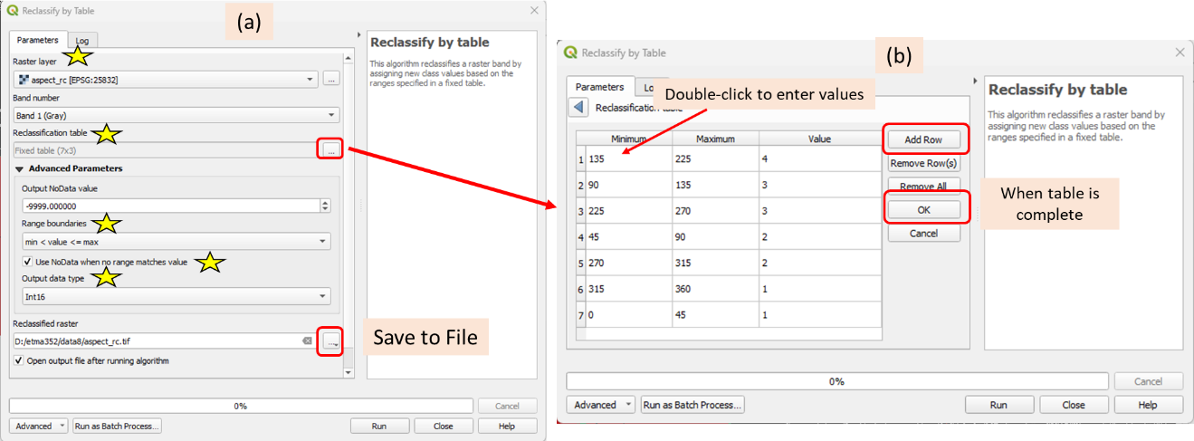

Figure . Aspect reclassify algorithm

*3.7 Styling the reclassified aspect layer*

1. Style the aspect_rc layer using the Layer Styling  icon as follows (Figure 20):

* Target layer: aspect_rc
* Render type: Paletted/Unique values
* Color ramp: Click the downward arrow and select All Color Ramps then use RdY|Gn
* Click *Classify*
* The aspect_rc layer should look like in Figure 20.

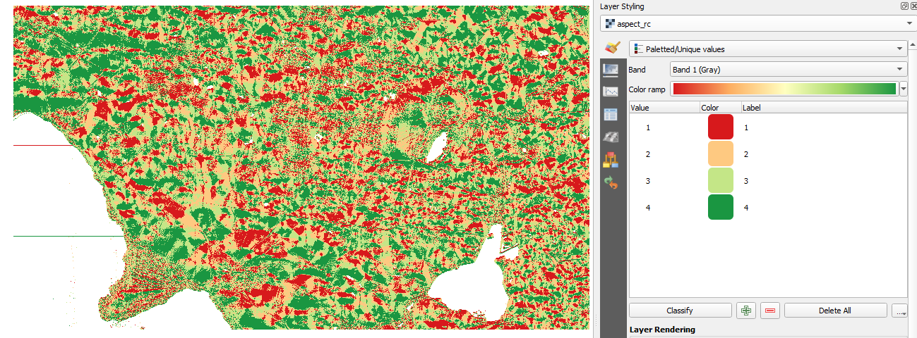

Figure 20. Reclassified and styled aspect layer

Part 4 – Using the Raster Calculator.

Now you will use the Raster Calculator in several ways to arrive at potential sites that meet the slope, aspect, and landcover criteria. The raster Calculator allows you to combine raster datasets mathematically to produce new outputs. For example, raster datasets can be added, subtracted, multiplied, and divided against one another. This procedure is known as raster algebra.

*4.1 Computing the Mean Slope and Aspect*

In the first operation, you will add the two reclassified terrain rasters (slope_rc and aspect_rc) together and divide by 2 to get the mean value.

$$\frac{slope+aspect}{2}$$

Since each raster has ideal conditions coded as “4”, an area that ends up with a pixel value of 4 would be ideal.

1. From the main menu, choose *Raster* – *Raster Calculator*

In the Raster Calculator window (Figure 21), the loaded raster datasets are listed in the upper left window. Their names are followed by an @ and the band number and since they are all single band images, their names will end with @1. Below it is a panel of operators and an expression window. To the right are options for saving out the resulting raster, including Spatial extent and Resolution. The rasters can be selected by double-clicking them while the operators can be used by clicking them. When the raster is selected, it will appear in the *Raster Calculator Expression* window enclosed in quotation marks “…”.

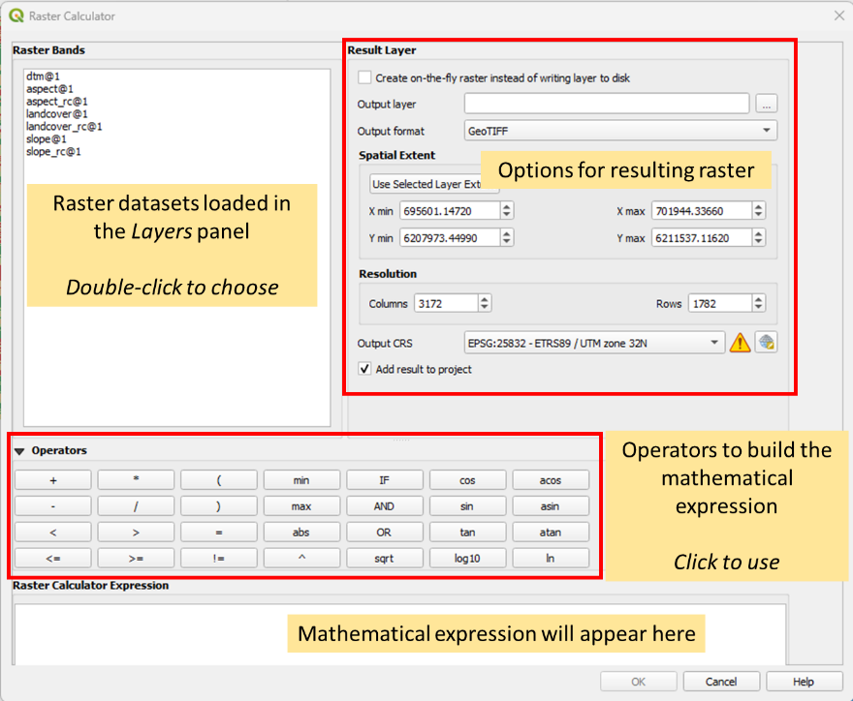

Figure . Raster Calculator

2. Under the operator, write the equation for the mean slope and aspect (Figure 22) following the steps below (Note: DO NOT type entries except for numbers)

* click (
* double-click slope_rc@1
* click +
* double-click aspect_rc@1
* click )
* click /
* type 2

3. Save the Output layer as *slope_aspect_mean*

4. Click OK

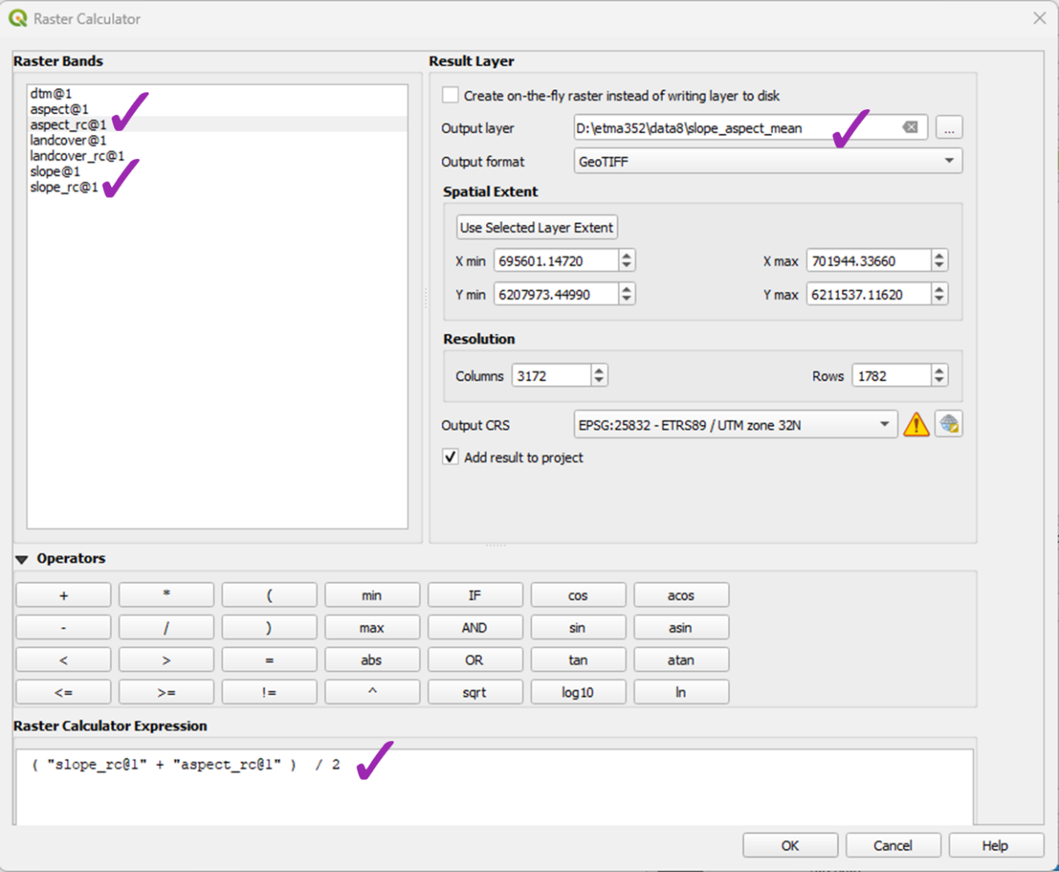

Figure . Raster Calculator

*4.2 Filtering Out the Unsuitable Landcover*

Next, you will essentially filter the results with the *lancover_rc* raster. Since this raster consists of 0’s and 1’s you will multiply the *slope_aspect_mean@1* raster by the *landcover_rc@1* raster. Any pixels in unsuitable landcover classes will receive a value of 0.

1. From the main menu choose Raster – Raster Calculator

2. In the Raster Calculator, write the expression “slope_aspect_mean@1” * “ landcover_rc” (see Figure 23)

3. Call the Output layer *rawresult* (Figure 23)

4. Click OK

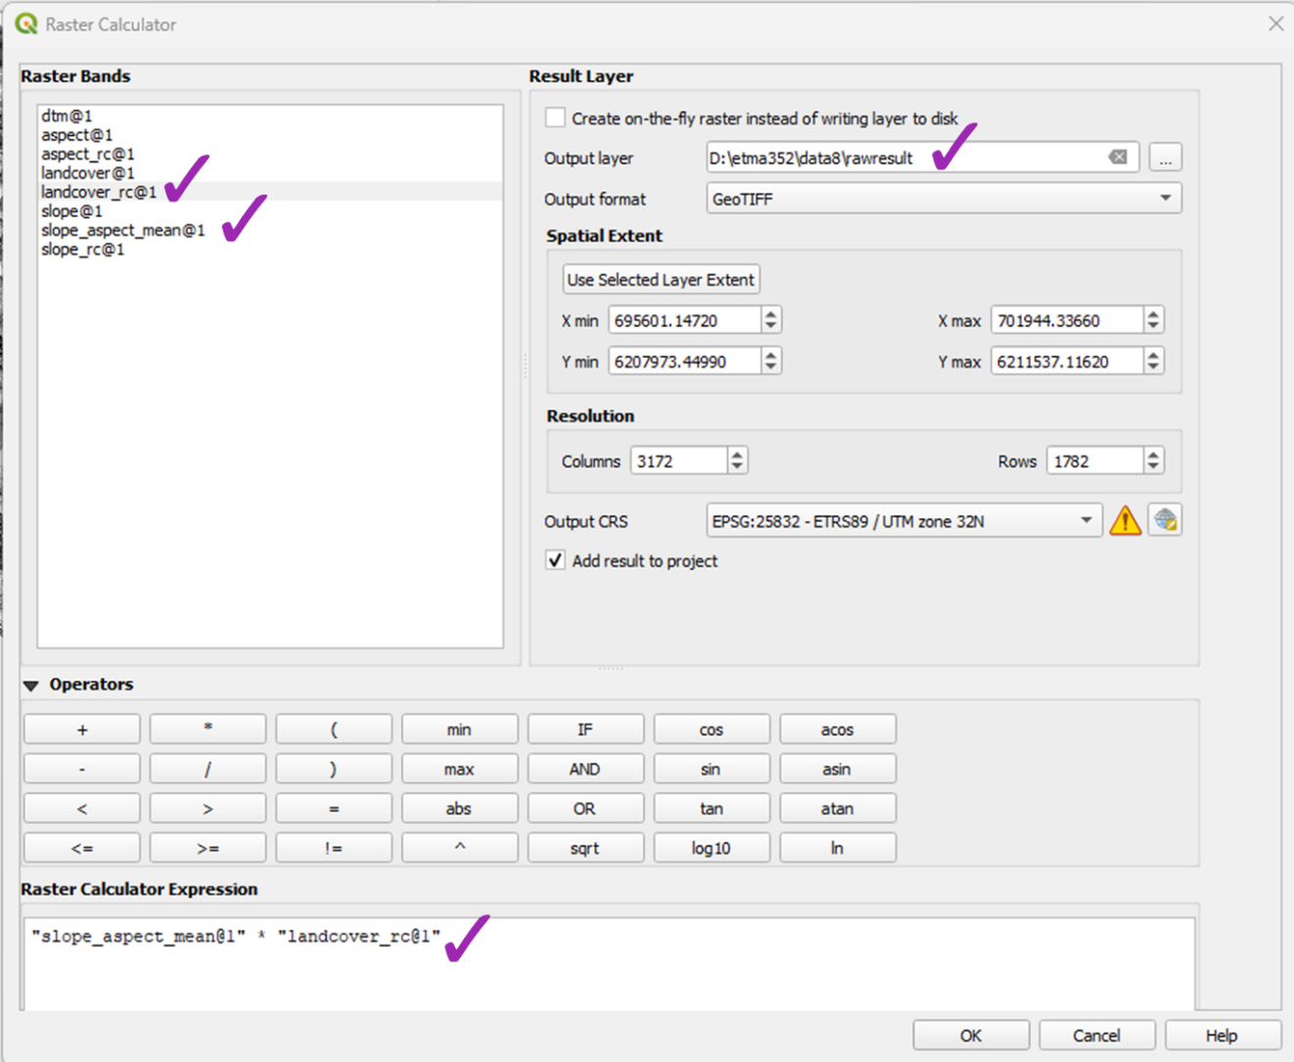

Figure . Raster Calculator for the final expression

The *rawresult* raster contains values from 0 to 4 where a value of 4 is ideal and anything closer to 1 is not. You will use a threshold value of 3.5 yp identify potential locations of the vineyard based on slope, aspect, and landcover.

4. Again from the main menu, open the Raster Calculator (Figure 24)

5. Enter the following expression “rawresult@1 >= 3.5.

6. Call the Output layer “finalresult”

7. Click OK

This will result in a binary output. The pixels with a value greater than 3.5 where the pixels have values equal to or greater than 3.5 will have a value of 1 and all other pixels will have a value of 0. The output pixels with a value of 1 will be the potential sites.

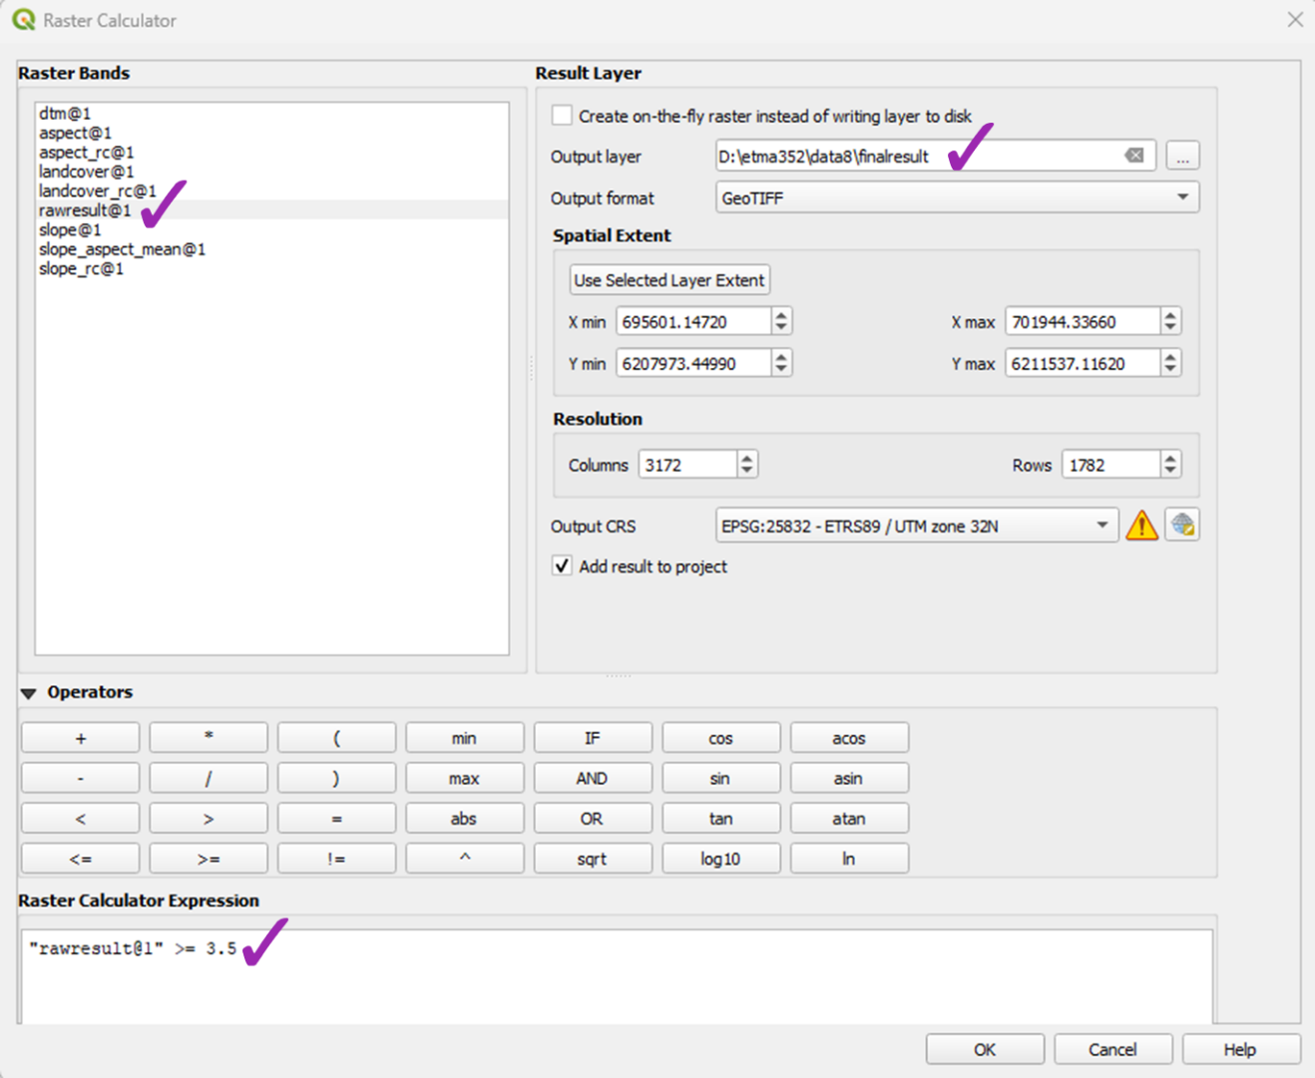

Figure . Raster Calculator for binary output

*4.3 Style the final result binary raster*

1. Style the finalresult layer using the Layer Styling  icon as follows (Figure 25):

* Target layer: finalresult
* Render type: Paletted/Unique values
* Color ramp: color ramp of your choice
* Click *Classify*
* Since you are only interested in the suitable sites, you can remove the unsuitable sites
  + Select the 0 class
  + Click the minus button to remove it (Figure 25)
  + Change the label from 1 to “suitable sites”
  + Edit your color choice to something with yellow palette
* The finalresult layer should look like in Figure 26.

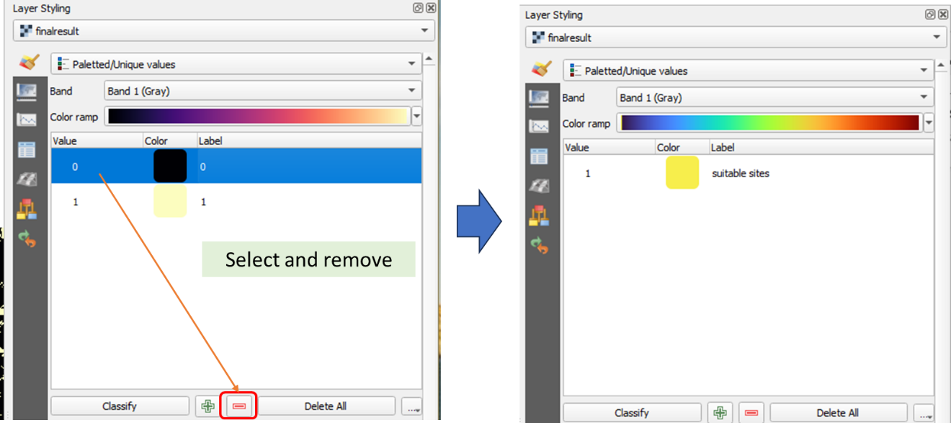

Figure . Styling the finalresult layer

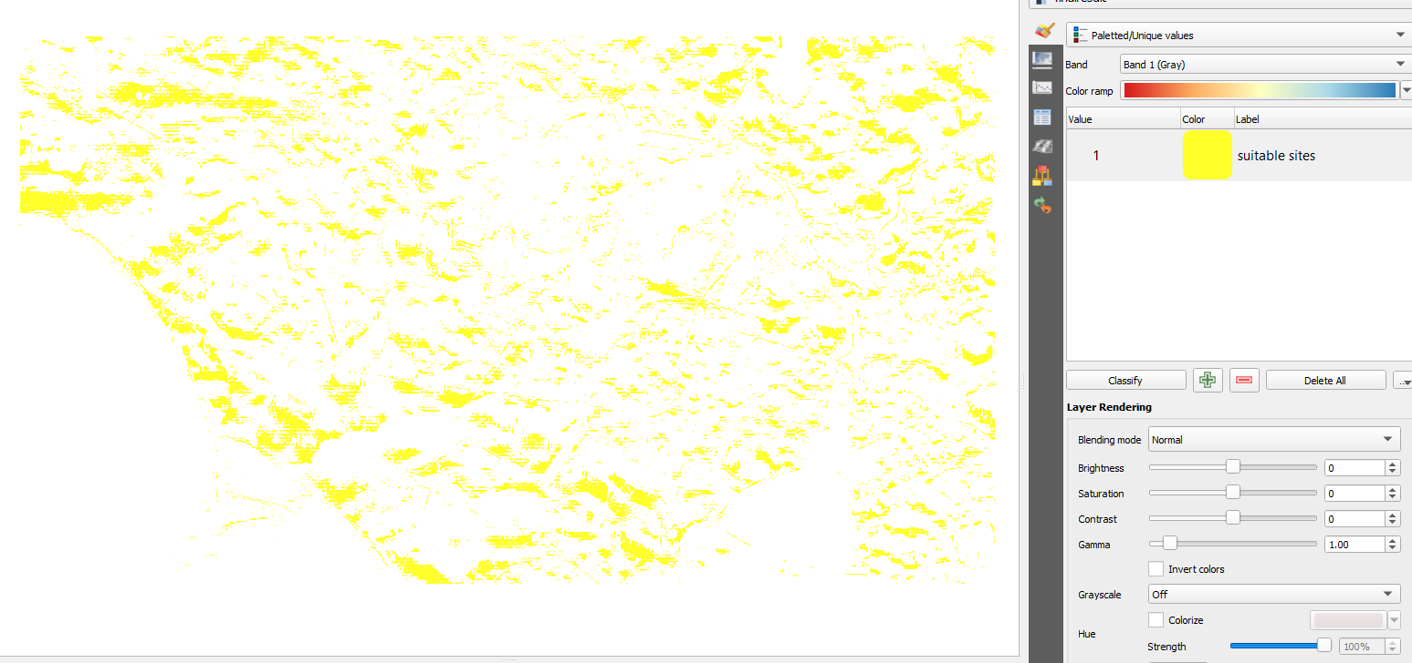

Figure . Finalresult layer

You will present the finalresult layer on top of the satellite image of the study area. For this, you will need to add the Satellite image of the study area from Google.

1. From the main menu choose *Plugins* – *Manage and Install Plugins.*

2. In the *Plugins* window, search for and install *QuickMapServices* (you need to do this only once)

3. From the main menu choose *Web* – *QuickMapServices* – Settings (after installing the plugin, this option should be available – Figure 27a)

4. Click More Services tab – Get contributed pack – OK (Figure 27b, 27c)

5. Choose Google – Google Satellite (Figure 28)

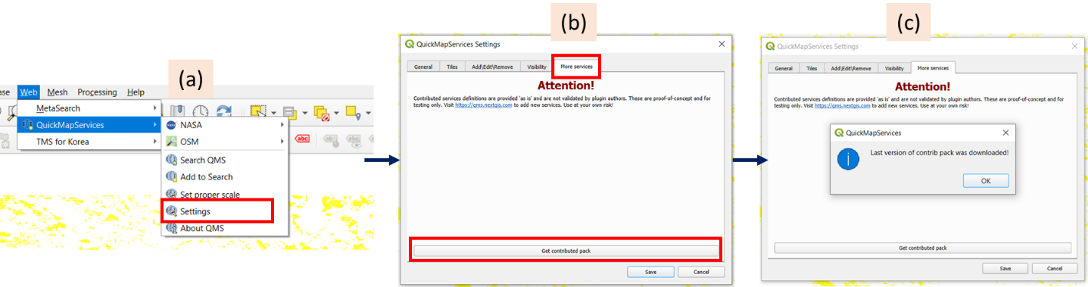  
Figure . QuickMapServices image

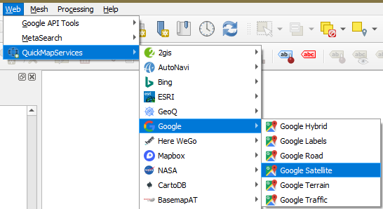  
*Figure 158. Loading the satellite image*

5. Arrange the layers in the Layers panel so that the finalresult layer is on top of the Google Satellite layer. Your map should look like in Figure 29 where the yellow pixels are the suitable sites for the vineyard.

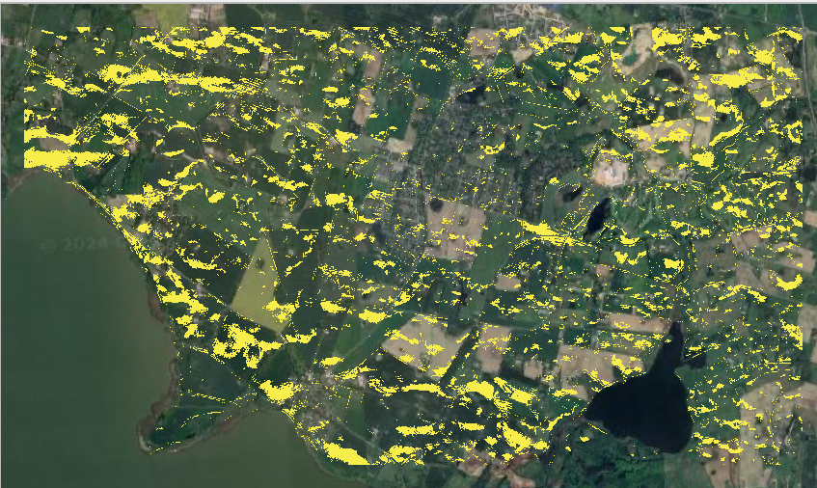

Figure 9. Suitable sites for the vineyard

Part 5 – Preparing the printable maps

You will prepare two printable maps. The *dtm* map with *Hillshade* and *Contour* (Figure 6) and the *finalresult* layer on top of the satellite image (Figure 29). You will create the Print Layout one at a time.

Before creating a printable map, right-click on one of the layers on the *Layers* panel and choose *Zoom to Layers* or simply click . This will give you zoom in view of the layers which will transfer to the print layout.

*5.1 dtm with Hillshade and Contour maps:*

1. In the Layers panel, disable the other layers except the *dtm, Hillshade, and Contour* layers

2. Click the New Print Layou icon 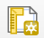 and create a printable map. Follow the steps from the previous lab exercise. Feel free to style your printable map but make sure to insert the following elements:

* Map Title: Area Terrain
* Your name and date
* North arrow
* Scale bar

3. Export your map as an image (*.PNG) and as a PDF file following the instructions in the previous lab.

4. Close Print Layout

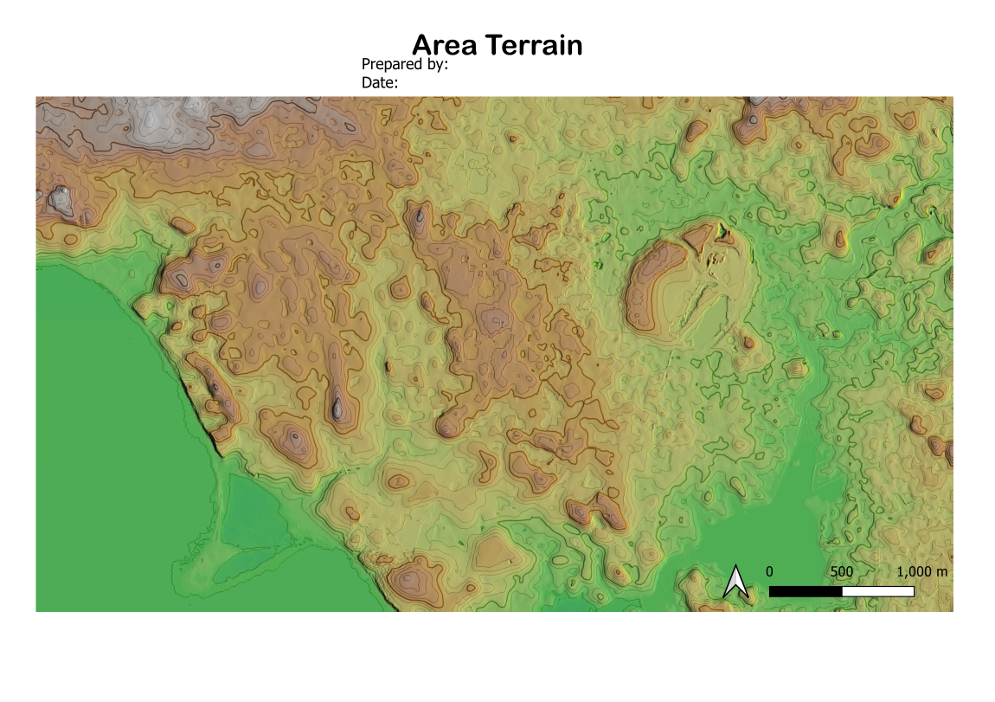

Figure . Printable terrain map

*5.2 Suitable sites map:*

1. In the Layers panel, disable the other layers except the  *finalresult and Google Satellite* layers

2. Click the New Print Layou icon  and create a printable map. Follow the steps from the previous lab exercise. Feel free to style your printable map but make sure to insert the following elements:

* Map Title: Suitable Sites for Vineyard
* Your name and date
* North arrow
* Scale bar
* Legend: All layers in the Layers panel will be added when you add the legend. We only want the legend from the layers in the finalresult map.
  + On the Item Properties panel (right side), delete all the layers except the finalresult. Uncheck Auto update (Figure 31a), then select the layers to delete ( hold Shift key and downward arrow), and click 
  + Change the titles of the layers. Double click the title to make them editable (Figure 31b). Change finalresult to “Vineyard Sites” and Band 1 (Gray) to “Location”
* Don’t forget to type the Title: Legend

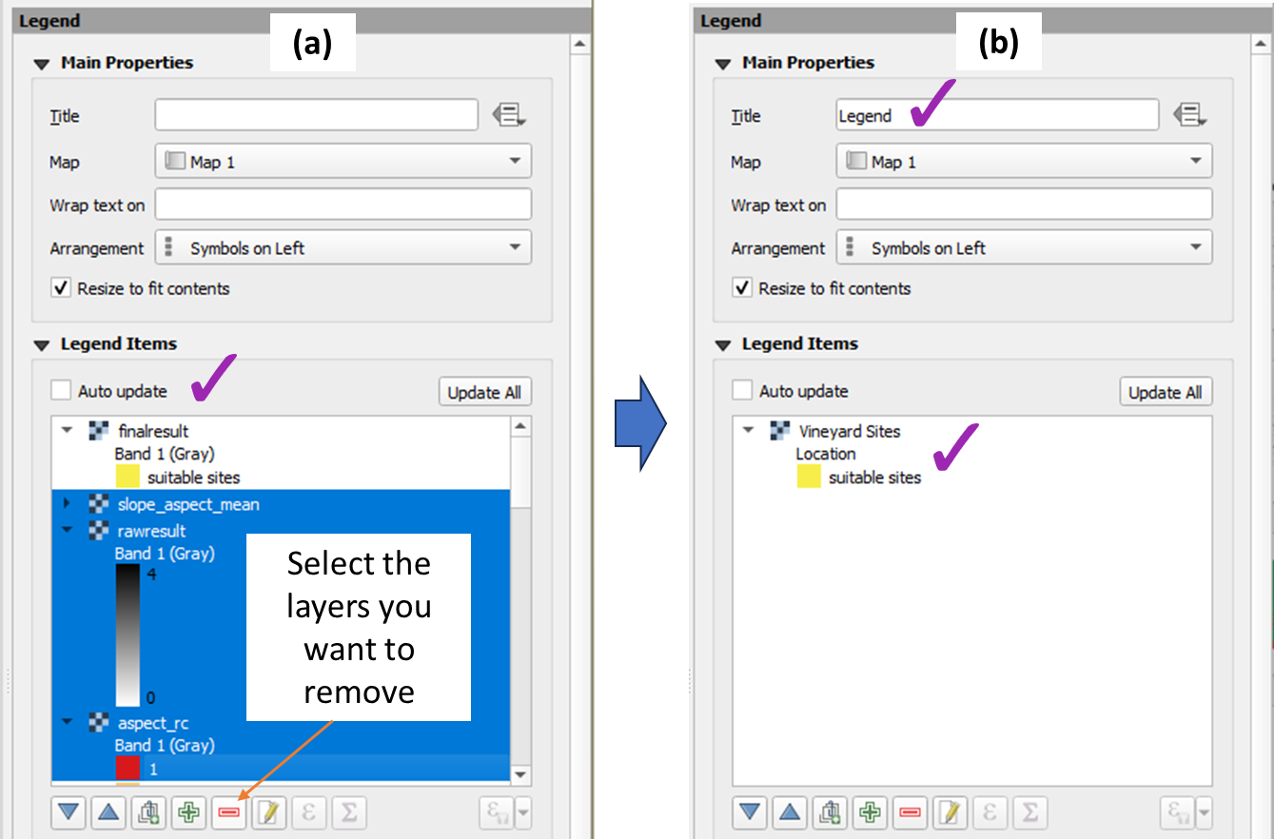

Figure 31. Editing the legend

3. The printable map should look something like in Figure 32

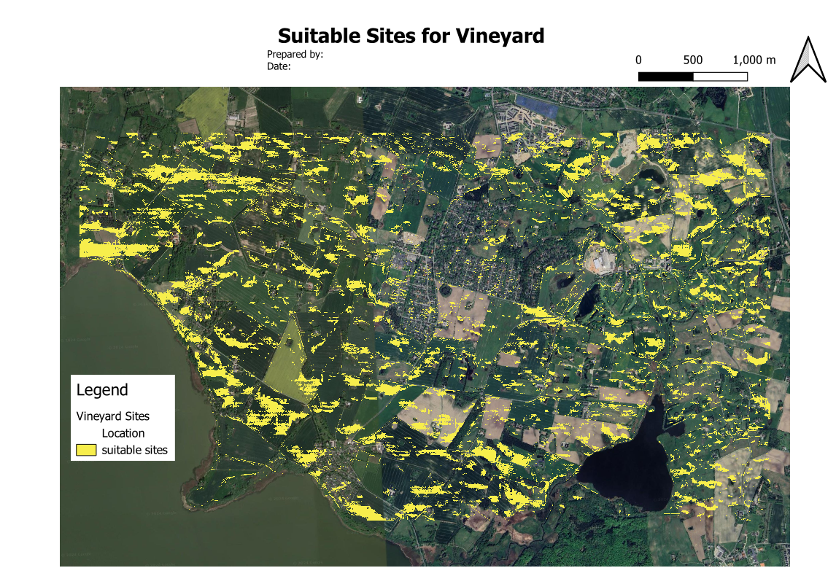

Figure . Printable map for suitable sites

4. Export your map as an image (*.PNG) and as a PDF file following the instructions in the previous lab.